**CSE102L Computer Programming Lab**

**LAB # 6**



**2020**

**Submitted to:**

**Engr. Abdullah Hamid**

**Submitted by:**

**TAYYABA**

**Registration No :**

**19PWCSE1854**

**Semester: 2nd**

**Class Section:** **C**

“On my honor, as student of University of Engineering and Technology,

I have neither given nor received unauthorized assistance on this

academic work.”

JUNE 27 , 2020

**Department of Computer Systems Engineering**

**University of Engineering and Technology, Peshawar**

## Objectives:

To understand function programming, its types and function-call.

## Tasks:

**Question No.1**

Write a program that takes marks as input and displays the grade using function.

**Program:**

**#include<iostream>**

**using namespace std;**

**int grade(int);**

**main()**

**{**

**int marks;**

**cout<<"Enter Your Marks: ";**

**cin>>marks;**

**grade(marks);**

**return 0;**

**}**

**int grade(int marks)**

**{**

**if( marks >= 90 && marks <= 100)**

**cout<<" A Grade";**

**else if( marks >= 80 && marks < 90)**

**cout<<" B Grade";**

**else if( marks >= 70 && marks < 80)**

**cout<<" C Grade";**

**else if( marks >= 60 && marks < 70)**

**cout<<" D Grade";**

**else**

**cout<<" F Grade";**

**}**

**Output:**

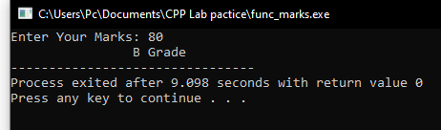

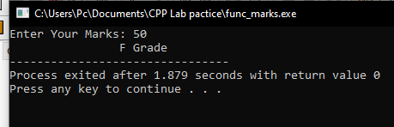

**Question No.2**

Write a function min max() that takes four integers as input and display the minimum and maximum number.

**Program:**

**#include <iostream>**

**using namespace std;**

**int max(int num[4]);**

**int min(int num[4]);**

**int main()**

**{**

**int num[4], maxi, mini;**

**for(int i = 0 ; i < 4 ; i++)**

**{**

**cout<<" Enter Your "<<i+1<<" Number: ";**

**cin>>num[i];**

**}**

**maxi = max(num);**

**mini = min(num);**

**cout<<"The Maximum value in four numbers you entered is "<<maxi<<endl;**

**cout<<"The Minimum value in four numbers you entered is "<<mini<<endl;**

**}**

**int max(int arr[4])**

**{**

**int maxi = arr[0];**

**for(int i = 1; i <= 4 ; i++)**

**{**

**if(maxi < arr[i])**

**maxi = arr[i];**

**}**

**return maxi;**

**}**

**int min(int arr[4])**

**{**

**int mini = arr[0];**

**for(int i = 1; i <= 4 ; i++)**

**{**

**if(mini > arr[i])**

**mini = arr[i];**

**}**

**return mini;**

**}**

**Output:**

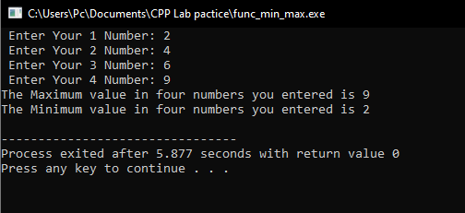

**Question No.3**

Your program should have a function named ‘prime’ which accepts an integer and return a Boolean (a true if the number is prime and false otherwise).

**Program:**

**#include<iostream>**

**using namespace std;**

**bool prime(int num);**

**main()**

**{**

**int num;**

**bool IsPrime;**

**cout<<"Enter Your Number : ";**

**cin>>num;**

**IsPrime = prime(num);**

**if(IsPrime)**

**cout<<"The Number You Entered Is A Prime Number "<<endl;**

**else**

**cout<<"The Number You Entered Is Not A Prime Number ";**

**}**

**bool prime(int n)**

**{**

**bool isprime=true;**

**for(int i = 1; i < 2; i++)**

**{**

**if(n % i == 0)**

**{**

**isprime = false;**

**break;**

**}**

**return isprime;**

**}**

**}**

**Output:**

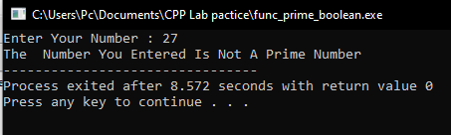

**Question No.4**

Write a program to find a factorial of user input number. Use function to find factorial.

**Program:**

**#include <iostream>**

**using namespace std;**

**int factorial(int n);**

**int main()**

**{**

**int n;**

**cout << "Enter a positive integer: ";**

**cin >> n;**

**cout << "Factorial of " << n << " = " << factorial(n);**

**return 0;**

**}**

**int factorial(int num)**

**{**

**int fact = 1;**

**for(int i = 1; i <= num; i++)**

**{**

**fact *= i;**

**}**

**return fact;**

**}**

**Output:**

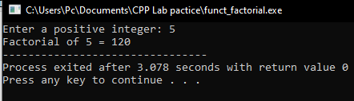

**Question No.5**

Given an integer number; you have to find the total number of minimum bit(s) which can be used to store given integer number. Implement the program using function. Function will take the integer as input and return the number of bits required.

**Program:**

**#include <iostream>**

**using namespace std;**

**int cBit(int);**

**int main()**

**{**

**int num;**

**cout<<"Enter an integer number : ";**

**cin>>num;**

**cout<<"Total number of bits required = "<<cBit(num);**

**}**

**int cBit(int n)**

**{**

**int count = 0, i;**

**if(n == 0)**

**return 0;**

**for(i = 0; i < 32; i++)**

**{**

**if( (1 << i) & n)**

**count=i;**

**}**

**return ++count;**

**}**

**Output:**

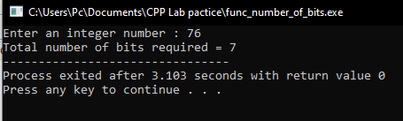

**Question No.6**

Write a program to find the roots of a quadratic equation of type a.x2+b.x+c where a is not equal to zero.

**Algorithm for function roots():**

Read the coefficients of a quadratic equation a, b, c

Calculate determinant d = b*b – 4*a*c

If d > 0 calculate two real roots r1 = (-b + sqrt(d)) / (2*a) and r2 = (-b + sqrt(d)) / (2*a)

If d=0 then roots r1 and r2 are equal and display r1 = r2 = -b / (2*a)

If d < 0 then roots are imaginary and display real root= -b /(2 * a) and img root =sqrt(-d) / (2*a)

**Program:**

**#include<iostream>**

**#include<cmath>**

**using namespace std;**

**int roots(int a, int b, int c);**

**main()**

**{**

**int A,B,C;**

**cout<<"ax^2 + bx + c = 0 \t i.e a is not equal to zero\n";**

**cout<<"Please Enter Value of a , b and c respectively :";**

**cin>>A>>B>>C;**

**cout<<A<<"x^2 + "<<B<<"x + "<<C<<" = 0"<<endl;**

**roots(A, B, C);**

**}**

**int roots(int a, int b, int c)**

**{**

**float d,r1,r2;**

**d = (b*b) - (4*a*c);**

**if (d>0)**

**{**

**r1 = (-b + sqrt(d))/(2*a);**

**r2 = (-b - sqrt(d))/(2*a);**

**cout<<"The Roots Are Real \n Root 1 = "<<r1<<"\n Root 2 = "<<r2<<endl;**

**}**

**else if(d==0)**

**{**

**r1= -b/(2*a);**

**r2=r1;**

**cout<<"Both The Roots Are Equal \t i.e. Root 1 = Root 2 = "<<r1;**

**}**

**else if(d<0)**

**{**

**r1 = -b/(2*a);**

**r2 = sqrt(d)/(2*a);**

**cout<<"The Roots Are Imaginary\n Real Roots : "<<r1<<"\n Imaginary Roots : "<<r2;**

**}**

**}**

**Output:**

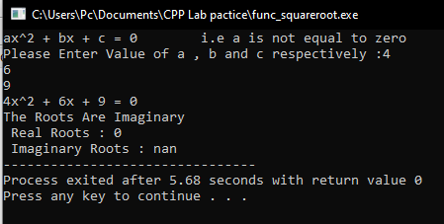

**Question No.7**

Write Program to compute Sin(x) using Taylor series approximation given by

Sin(x) = x - (x3/3!) + (x5/5!) - (x7/7!) + …….

Compare the result with the built- in Library function and print both the results.

#define PI 3.14159265

float mysin( float deg )

{

... //implement the function here

}

int main ()

{

double param, result,result2;

param = 30.0; //take it as input from user

result = sin (param*PI/180);

result2 = mysin (param*PI/180);

cout<< "The sine of " << param <<" degree using builtin function is "

<< result;

cout<<"The sine of "<<param<<"degree using user defined function is "

<< result2;

return 0;

}

Note: Use separate function for power and factorial

**Program :**

**#include <iostream>**

**#include <cmath>**

**using namespace std;**

**int factorial(int num){**

**int fact = 1;**

**for(int i = 1; i <= num; i++)**

**{**

**fact *= i;**

**}**

**return fact;**

**}**

**float taylorSine(float num, float precision = 19){**

**int value = 0;**

**for(int n = 0; n < precision; n++)**

**{**

**value += pow(-1.0, n) * pow(num, 2*n+1) / factorial(2*n + 1);**

**}**

**return value;**

**}**

**int main(){**

**cout<<"Biult-in Library sin\t Taylor series sin"<<endl;**

**for(int i = 1; i <= 10; i++)**

**{**

**cout << sin((float) i) << " \t =\t" << taylorSine((float)i) << endl;**

**}**

**}**

**Output:**

